**Module 7 - Spring REST using Spring Boot 3**

**HandsOn 2**:Hello World RESTful Web Service

**QUESTION:**

Write a REST service in the spring learn application created earlier, that returns the text "Hello World!!" using Spring Web Framework. Refer details below:  
  
**Method:** GET  
**URL:** /hello  
**Controller:** com.cognizant.spring-learn.controller.HelloController  
**Method Signature:** public String sayHello()  
**Method Implementation:** return hard coded string "Hello World!!"  
**Sample Request**: http://localhost:8083/hello  
**Sample Response:** Hello World!!   
  
**IMPORTANT NOTE**: Don't forget to include start and end log in the sayHello() method.  
  
Try the URL http://localhost:8083/hello in both chrome browser and postman.  
  
SME to explain the following aspects:

* In network tab of developer tools show the HTTP header details received
* In postman click on "Headers" tab to view the HTTP header details received

**Solution:**

**Step 1: Created Controller Class**

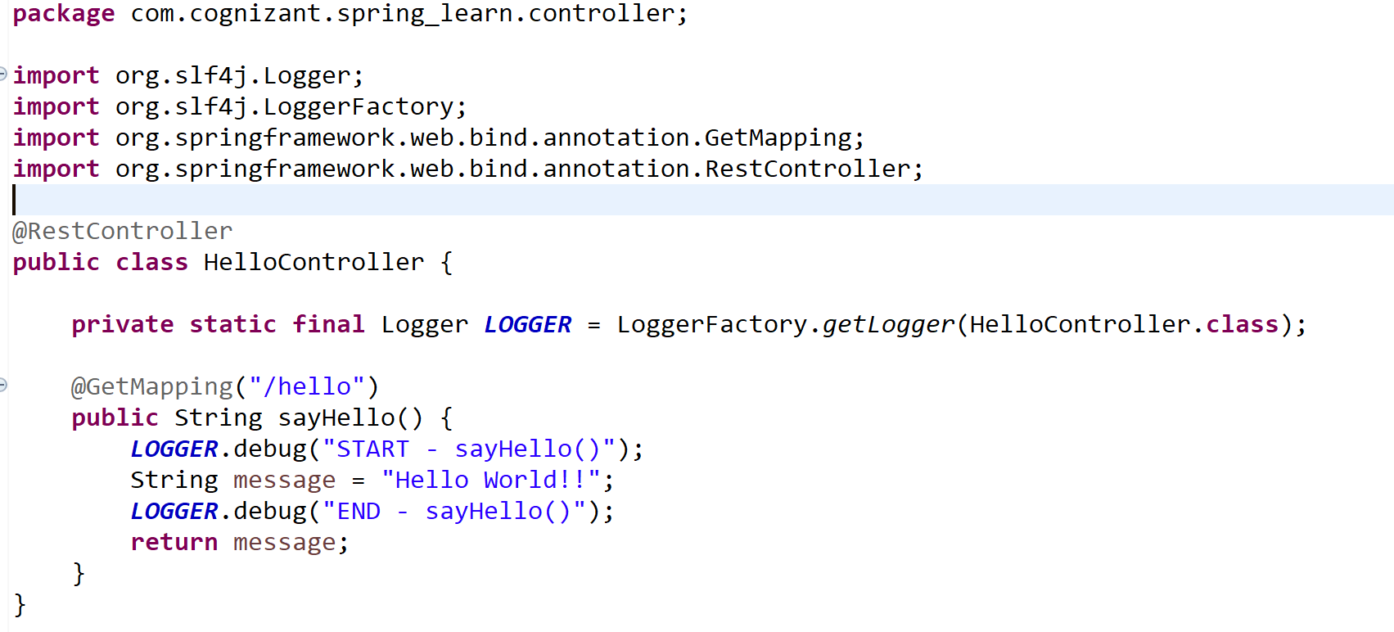

**Step 2: Configured Application Port**

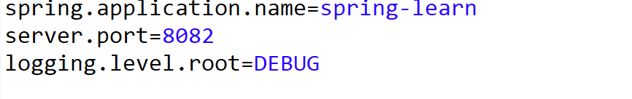 \

**Step 4: Tested the Endpoint**

